Week: 6
Experiment: 4

“Isolation of DNA from Different Sources like Human Cheek Cells, Green Peas, Papaya, and Mango Samples”

Total Marks (30 Marks):
1) Lab Performance (10 Marks):
2) Observation (16 Marks):
a) For Papaya DNA Extraction:
Reagent | Effects and Observations
Washing Liquid | It breaks the cell membrane and nuclear envelope which releases DNA
1 ml of 5% of NaCl solution | Helps DNA precipitate by neutralizing its negative charge, allowing it to clump together
Papaya sample | Source of papaya cell
Isopropanol | DNA gets out of solution and is visible as white thread/ cloudy strands.

b) For PEAS DNA Extraction:
Reagent | Effects and Observations
5% NaCl Solution | Neutralizes the negative charges on DNA and helps proteins breaking, making DNA easier to separate.
Washing liquid | Breaks down Cell membranes and nuclear membranes. Solution appears to be slightly foamy and translucent.
Cold ethanol | separate layer above the aqueous extract. DNA, which is insoluble in cold ethanol, begins to precipitate into this alcohol layer. A white cloudy interface forms between alchol and extract. After waiting for 5 mins, we observerd visible dna strands.

c) For Human DNA Extraction:
Reagent | Effects and Observations
NaCl Solution | Neutralizes the negative charge on DNA, Helps breakdown protein chains that bind dna. Cheek cells from your mouth are dislodged and mixed into the saltwater.
Washing liquid | The detergent breaks open (lyses) the cell and nuclear membranes by dissolving their lipid bilayers, We noticed white big threads type structure forming in the water.
Isopropyl Alcohol | DNA will start to form and youll see small threads like structure of white colour. Cold alcohol reduces DNA solubility, causing it to precipitate.
Food Color | The food coloring just helps you see the DNA layer more clearly.
d) For Mango DNA Extraction:
Reagent | Effects and Observations
Mango Pulp | Source of DNA cell
Nacl Solution | Helps breaking down cell membrane and nucleas membrane.
Washing Liquid | The detergent breaks open (lyses) the cell and nuclear membranes by dissolving their lipid bilayers, Makes the solution foamy and less opaque
Cold ethanol | Cold ethanol (less dense) forms a separate top layer above the mango extract. DNA, which is insoluble in ethanol, starts to move into the ethanol layer. We observed orange liquid below, clear ethanol above with a cloudy foam forming. That were dna strands.

3) Results (3 Marks):
Saliva DNA Extraction
- After gargling with salt water and adding detergent, the solution appeared foamy with white small balls like structures.
- Upon adding cold ethanol, a layer formed, white strands of DNA became visible in test tube.
- These strands gradually clumped together and could be seen floating in solutions.
Green Peas DNA Extraction
- Grinding and filtering produced a green liquid extract.
- After adding NaCl and detergent, the solution became slightly translucent and foamy.
- When ethanol was added, a cloudy white layer appeared at the ethanol boundary.
- After a few minutes, white, stringy DNA fibers formed.
Mango Pulp DNA Extraction
- Filtering the pulp produced an orange yellowish liquid solution.
- Addition of NaCl and detergent caused slight foaming, but the solution color was still orange.
- After adding cold ethanol, a separate clear layer formed on top of the orange extract.
- In the test tube, white cloudy strands of DNA became visible.
- The DNA appeared as sticky, mucus like thread structure.
Papaya DNA Extraction
- Filtering produced a yellow liquid from the papaya pulp.
- After adding NaCl and detergent, the solution became slightly foamy while retaining its yellow color.
- When cold ethanol was added, two clear layers formed: the papaya extract at the bottom and ethanol at the top.
- Within a few minutes, a white, stringy, cloudy layer of DNA appeared.

4) Take pictures of the test tubes and paste them below (1 Mark):
PEAS:-
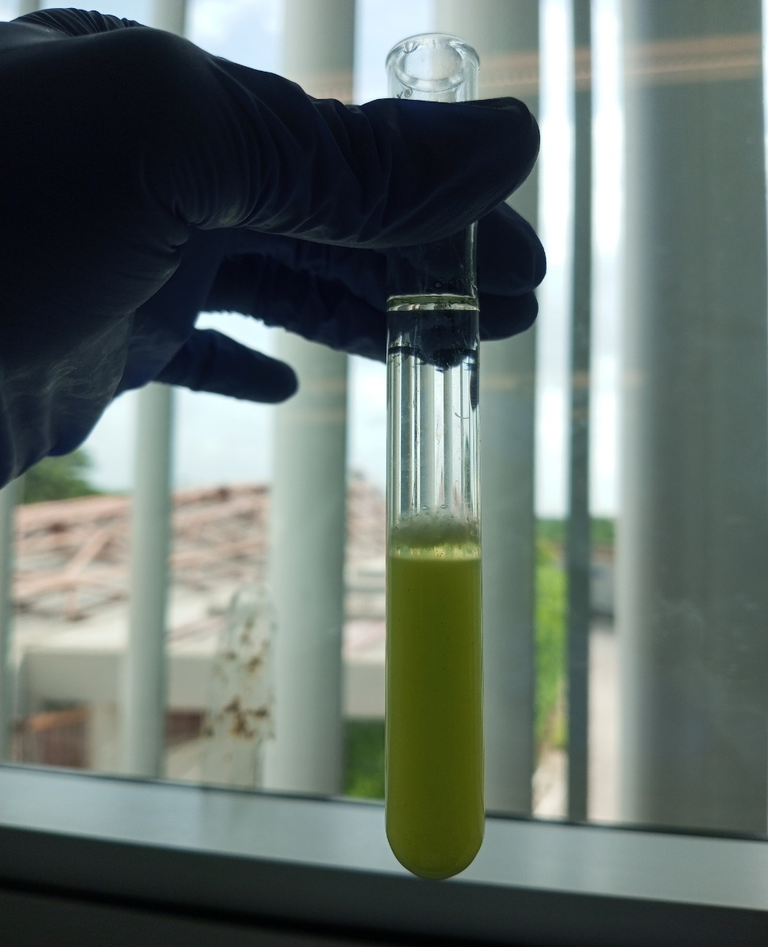

MANGO:-
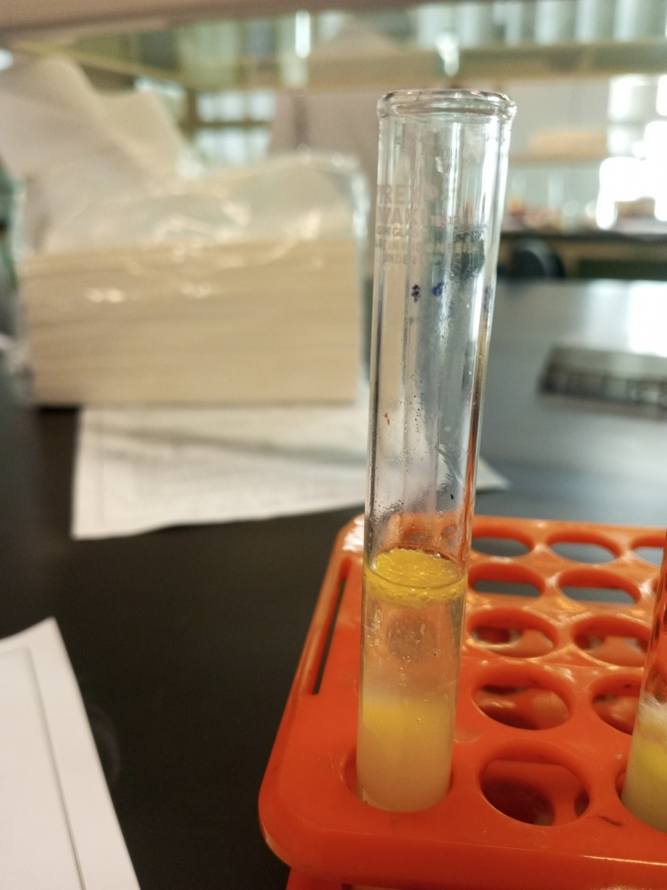

SALIVA:-
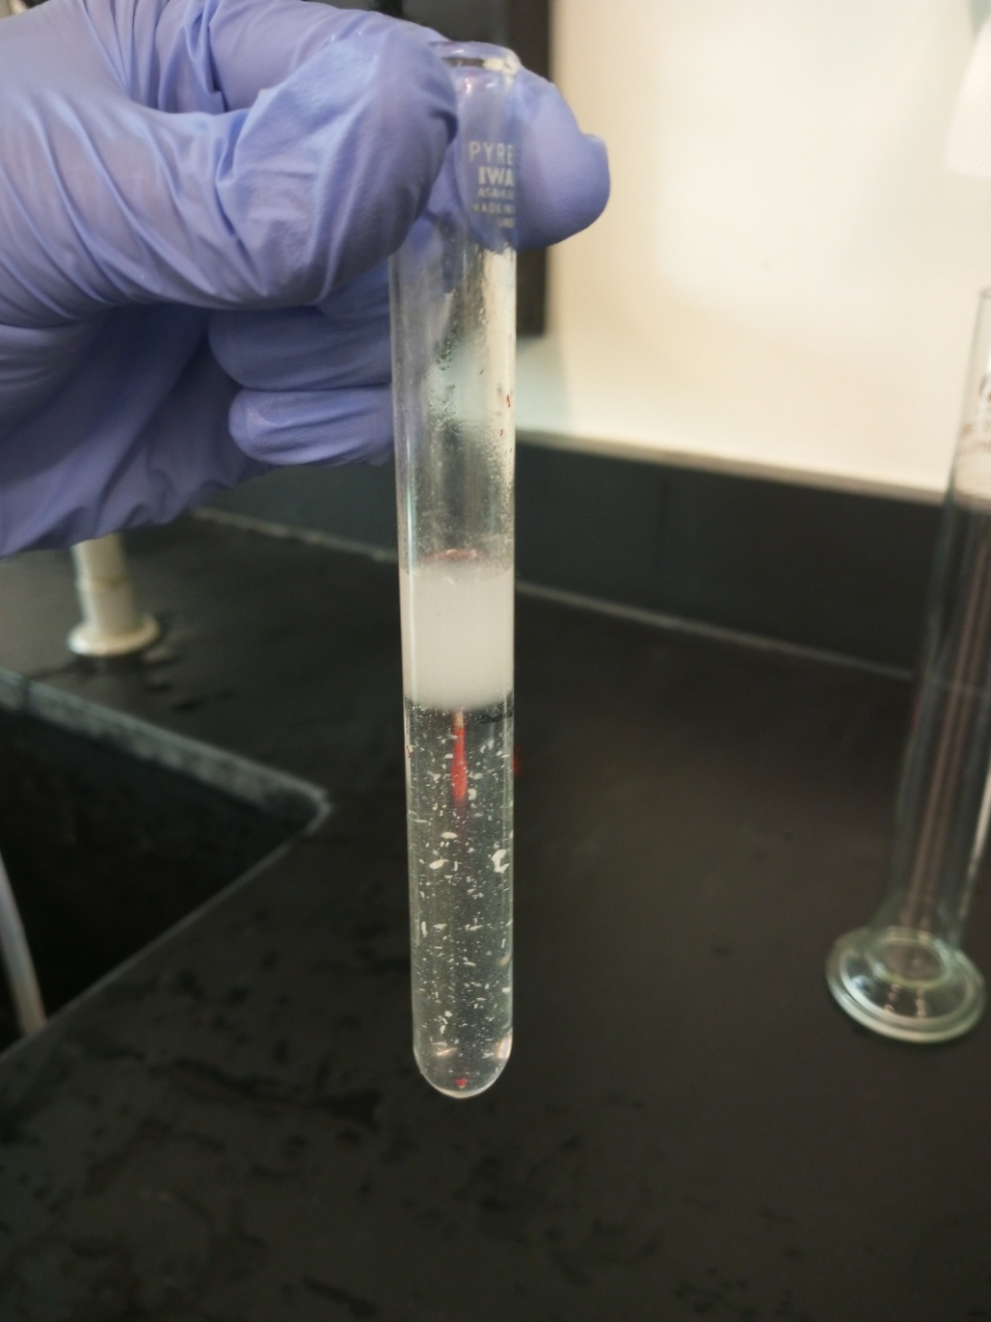

PAPAYA:-
